**DELHI SKILL AND ENTERPRENEURSHIP UNIVERSITY**

**Linux Programming & Administration**

***PRACTICAL FILE***

**BCA-II**

**Submitted To: Submitted By:**

**Dr.Shilpa Bahl Name: RITIK KUMAR**

**(Professor) Class:BCA SEM2ND**

**Enrolment No: 412221121**

**Instructions:**

**Que 1 Write the linux command to display calendar with various options**

**Que 2 Write a linux command to display date with various options.**

**Que 3 Write a linux command to display the list of users who are currently using linux server.**

**Que 4 Write a linux command to display your system details.**

**Que 5 Write a linux command to display your user name.**

**Que 6 Write linux command to list all the directories and files on the server.**

**Que 7 Write the linux command to display the content of a file**

**Que 8 Write the linux command to print the content on standard output device.**

**Que 9 Write the linux command to perform calculations.**

**Que 10 Write the linux command to show the current working directory. Que 10 Write the linux command to get help with various options.**

**Que 12 Write the linux command to display what all users are currently doing**

**Que 13 Write the linux command to create a directory.**

**Que 14 Write the linux command to change the directory**

**Que 15 Write the linux command to remove a directory.**

**Que 16 Write the linux command to delete a file. Linux Lab 2 NAME COURSE Roll No**

**Que 17 Write the linux Command to copy a file to some other location**

**Que 18 Write the linux command to move a file to some different location.**

**Que 19 Write the linux command to compare the contents of two files**

**Que 20 Write the linux command to count the number of words, lines and sentences in the file**

**Que 21 Write the linux command to see the data in octal format.**

**Que 22Write the linux command to give the alias name.**

**Que 23 Write the linux command to view the exiting aliases.**

**Que 24 Write the linux command to unalias the exiting alias name.**

**Que 25 Write the linux command to display the hostname of the system.**

**Que 26 Write the linux command to get information about the operating System.**

**Que 27 Write the linux command to display unique contents of a file.**

**Que 28 Write the linux command to view first 5 lines of a file.**

**Que 29 Write the linux command to view last 20 lines of a file.**

**Que 30 Write the linux command to extract specific column and field from a file.**

**Que 31 Write the linux command to merge two files vertically.**

**Que 32 Write the linux command to sort a file**

**Que 33 Write the linux command to find any character and replace it with some other character.**

**Que 34 Write the linux command to change the permission of an existing file in relative manner**

**Que 35 Write the linux command to change the permission of an existing file in absolute manner**

**Que 36 Write the linux command to create a hard link of a file Linux Lab 3 NAME COURSE Roll No Que 37 Write the linux command to create a soft link of a file as well as directory**

**Que 38 Write the linux command to search for specific pattern in a file.**

**Que 39 Write the linux command to print the result of a specific pattern.**

**Que 40 Write the linux command to replace any character/string with specified character/string using sed Command**

**Que 41 Write the linux command to show the use of awk Command**

**Que 42 Write the linux command to list the processes for the current shell(ps).**

**Que 43 Write the linux command to display detailed information about processes.**

**Que 44 Write the linux command to stop any currently running process**

**Que 45 Write the linux command to Kill a process**

**Que 46 Write the linux command to create a tar file**

**Que 47 Write the linux command to create a Zip file and Unzip it**

**Que 48 Write a shell script to find the largest of two numbers**

**Que 49 Write a shell script to check whether a number is even or odd**

**Que 50 Write a shell script to find largest of three given number.**

**Que 51Write a shell script to greet the user according to the week of the day.**

**Que 52 Write a shell script to display the number of vowels and consonants in a string**

**Que 53 Write a shell script to perform arithmetic operation using case---esac.**

**Que 54 Write a shell script to count words, lines and characters in a file**

**Que 55 Write a shell script to check whether the year entered is leap or not.**

**Que 56 Write a shell script to find factorial of a number.**

**Que 57 Write a shell script to generate a multiplication table**

**Que 58 Write a shell script to add the digits of a number**

**Que 59 Write a shell script to reverse a string.**

**Que 60 Write a shell script to check whether a number entered is prime or not**

**Que 1 Write the linux command to display calendar with various options**

**STEPS:**

Command: Calendar Syntax: **cal**

Description: This command displays the calendar on the screen.Options:

**Cal -3**

Description: This command displays three months –previous current and next

**Cal –s**

Description: This command displays the month with first day as Sunday

**Cal-m**

Description: This command displays the month with first day as Monday

**Cal –y( current ) or Cal -y 2019**

Description: This command displays calendar of whole year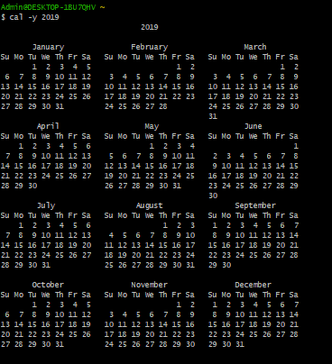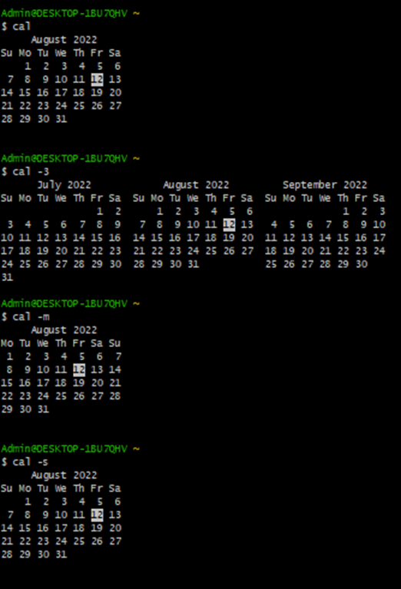

**Que 2 Write a linux command to display date with various options.**

**Command:** date

**Syntax:** date

**Description:** This command is used to display the current date with time. There are various methods to display date. Some of them are as follows:

* **Date:**  used to display the date with time.
* **%u:** used to display day of week (1..7); 1 is Monday.
* **%y:** used to display the year
* **%m**: used to display the current month.
* **%a or %A:** used to display the locale's abbreviated weekday name (e.g., Sun) or for full word.
* **%b or %B**:used to display month in short and long respectively. 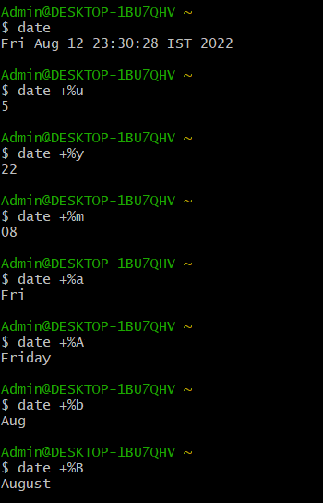

**Que 3 Write a linux command to display the list of users who are currently using linux server.**

Command: who

**Syntax: who**

Description: this command is used to display the list of users who are currently active on Linux server. There are various ways to implement this command. Some of them are as follows:

* **Who**: display the list of active users.
* **Whoami:** Show the user name.
* **Finger:** command is a user information lookup command which gives details of all the users logged in. This tool is generally used by system administrators. It provides details like login name, user name, idle time, login time, and in some cases their email address even.
* **w:**Lists all users currently on system and also shows what they all are doing
* **uname:**Uname is used to get information about the operating System. Uname command without parameter will only show the name of your operating system.

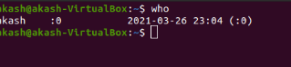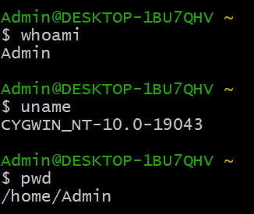

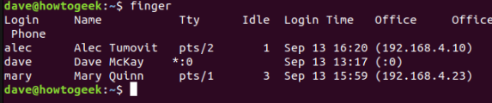

**Que 4 Write a linux command to display your system details.**

**$uname:** It is used to get information about the operating system uname command without parameter will only show the name of your operating system.

**Syntax:** **uname**

**Example:**

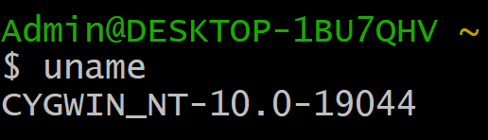

**$uname -s:** It display kernel name.

**Syntax:** **uname -s**

**Example:**

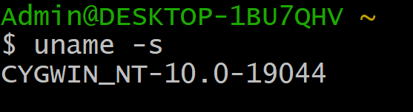

**$uname -n:** It display node host name.

**Syntax:** **uname -n**

**Example:**

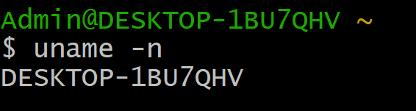

**$uname -i:** It display the hardware platform.

**Syntax:** **uname -i**

**Example:**

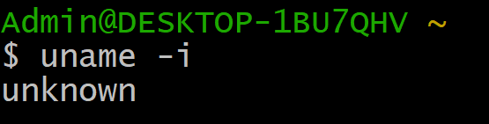

**$uname -o:** It display what operating system you are running.

**Syntax:** **uname -o**

**Example:**

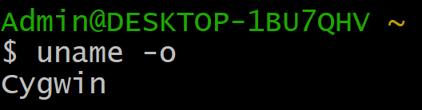

**Que 5 Write a linux command to display your user name.**

* **uname:**Uname is used to get information about the operating System. Uname command without parameter will only show the name of your operating system.

TYPE OF UNAME

* Uname -a :display all the detail of system.
* Uname -r :display the bit and version of system
* Uname -v :display the when was system started.
* Uname -m:display the how many bit of system.

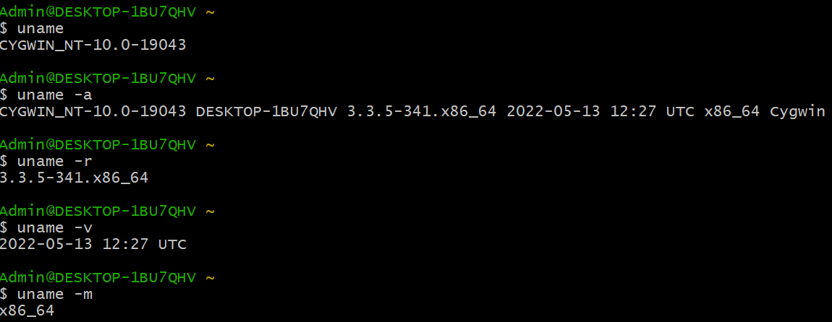

**Que 6 Write linux command to list all the directories and files on the server.**

* Ls :- it is use simple list file in current directory
* Ls -a:- It is used to show the list of all the files of the current directory including the hidden files.
* Ls -l:- It shows a list of all the files in a long list format.
* Ls -r:- It is used to print the list in reverse order. When you’re like
* Ls -lh:- it shows size in human readable form.

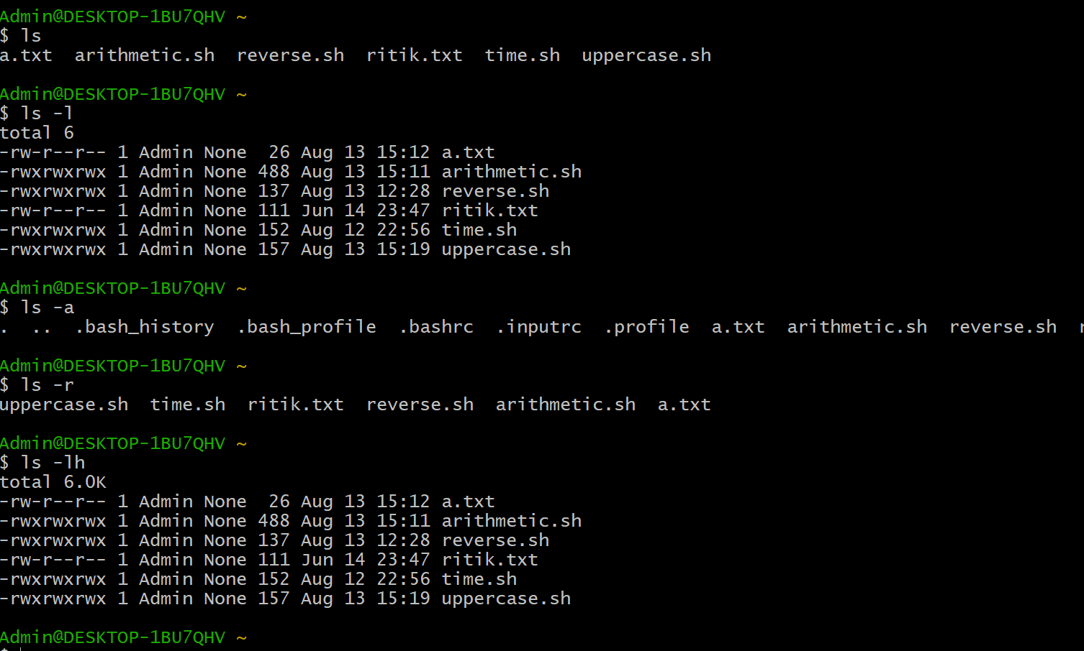

**Que 7 Write the linux command to display the content of a file**

### **Cat :**The simplest way to view text files in Linux is the cat command. It displays the complete contents in the command line without using inputs to scroll through it.

### **Head:**Sometimes the information needed is in the first lines of a file. In that case, use the head command to view the first ten lines of a file in Linux.

### **Tail:**While the cat command is helpful when dealing with a small file, it is not the best way to view large log files. The tail command allows viewing the last ten lines of a file

### **Tac:**Another exciting way to display the contents of a file in Linux is in reverse order. To do so, use the tac command. It is similar to cat but reversed, reading and displaying the file starting from the last line

**Que 8 Write the linux command to print the content on standard output device.**

**Output Redirection**

The output from a command normally intended for standard output can be easily

diverted to a file instead the terminal. This capability is known as output redirection.

If the notation > file is appended to any command that normally writes its output to

standard output, the output of that command will be written to file instead of your

Terminal.

**Input Redirection**

the less-than character < is used to redirect the input of a command.

The commands that normally take their input from the standard input can have their

input redirected from a file in this manner.

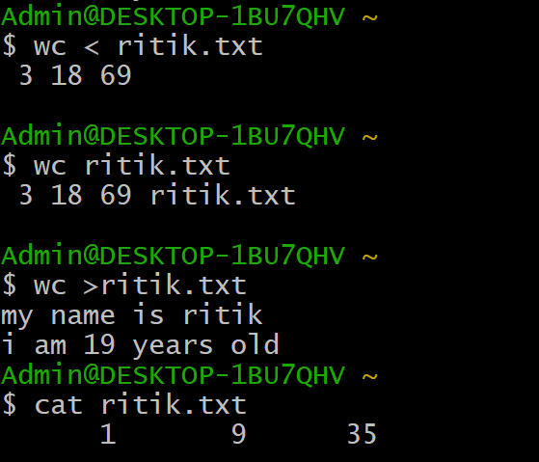

**Que 9 Write the linux command to perform calculations.**

**Bc**: command is used for calculators on Linux command prompt.

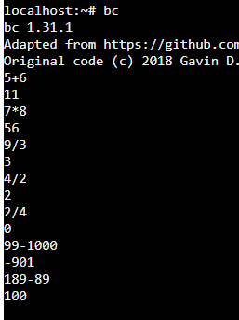

**Que 10 Write the linux command to show the current working directory.**

pwd (present working directory) – The pwd command is used to display the name of the current working directory in the Linux system using the terminal.

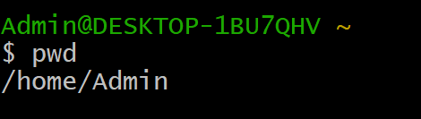

**Que 11 Write the linux command to get help with various options.**

**1. Help Command**

This command gives a short explanation about how to use a particular command for which we are taking the help.

It gives a list of available options .In short it gives a description about the functionality of the command and the detail of all the options for a specific command.

**Syntax :** Command name --help

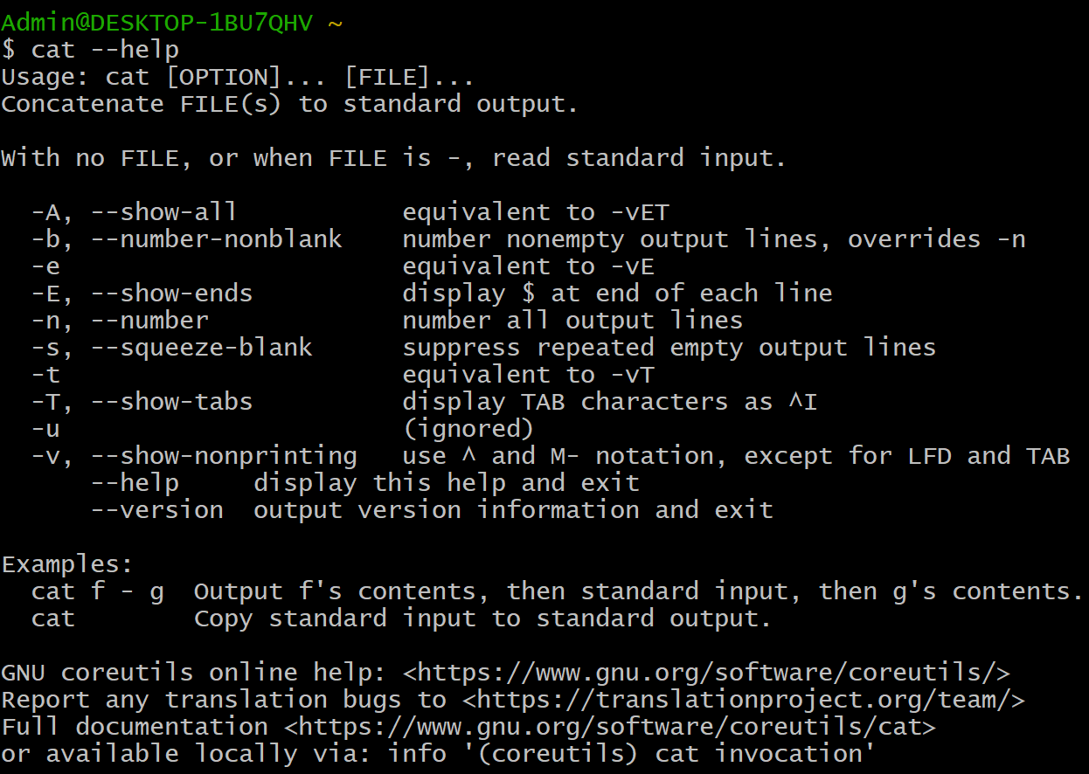

**2. Whatis Command**

It will give one line description about the command.

The whatis command shows one line summary of a command taken from its Man page.

**Syntax:** whatis command name

For example:- **whatis -v cal**



**3.** **Info Command**

In addition to the man pagesyou can read the info page about the command.

This command usually contains more recent information and is easier to use.

The man page for some commands refer to the info page.

**Syntax:** info command name

For example:- **info cal**

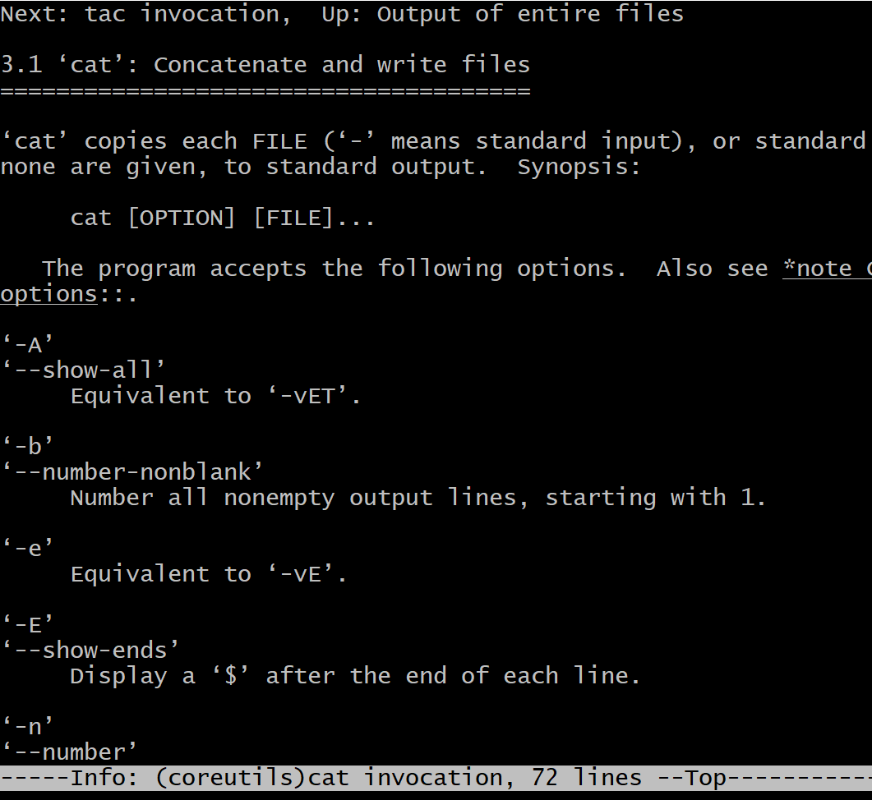

**4.** **Man Command**

Man command is use to display the user manual of any command it provide the detailed view of the command for example name of the command, description options, exit status, return values, errors, versions and authors.

**Syntax: -** man command name

For example: - **man cal**

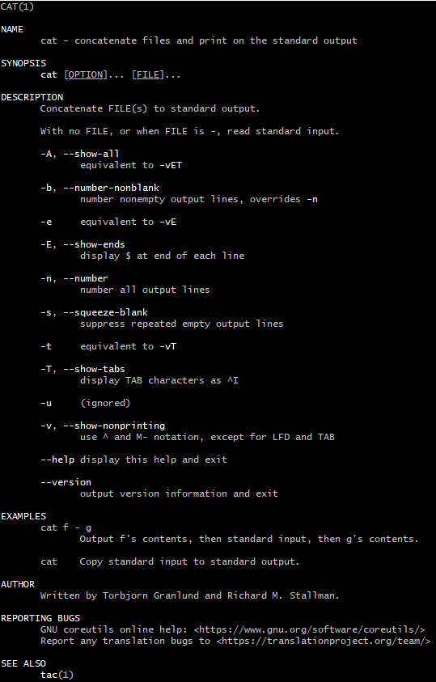

**Que 12 Write the linux command to display what all users are currently doing**

1. [**w** command](https://www.cyberciti.biz/faq/unix-linux-list-current-logged-in-users/#w_command) – Shows information about the users currently on the machine, and their processes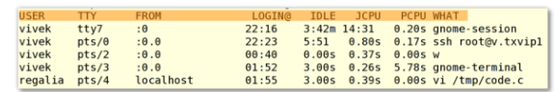

**Que 13 Write the linux command to create a directory.**

**mkdir Command**

The [mkdir](https://www.javatpoint.com/linux-mkdir) command is used to create a new directory under any directory.

Syntax: mkdir <directory name>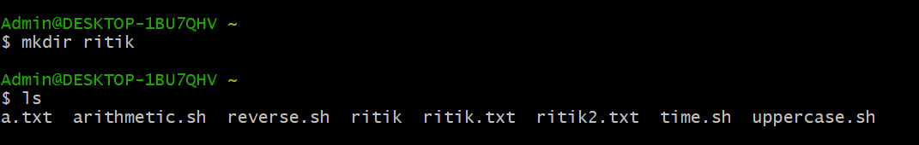

**Que 14 Write the linux command to change the directory**

**cd Command**

The [cd](https://www.javatpoint.com/linux-cd) command is used to change the current directory.

**Syntax: cd** <directory **name**>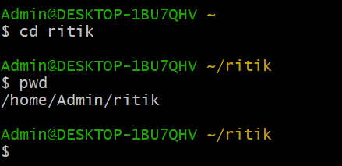

**Que 15 Write the linux command to remove a directory.**

**rmdir Command**

The [rmdir](https://www.javatpoint.com/linux-rmdir) command is used to delete a directory.

Syntax: **rmdir <directory name>** 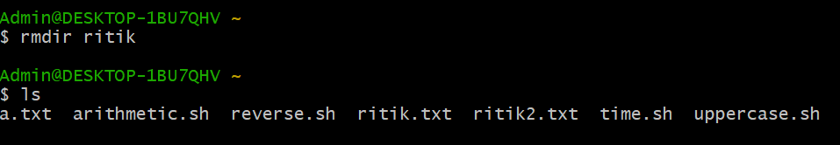

**Que 16 Write the linux command to delete a file. Linux Lab 2 NAME COURSE Roll No**

**rm Command**

The [rmdir](https://www.javatpoint.com/linux-rmdir) command is used to delete a file.

**Syntax: rmdir <file name>** 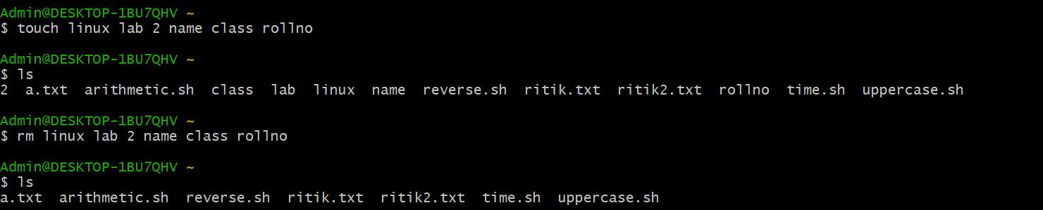

**Que 17 Write the linux Command to copy a file to some other location**

**cp Command**

The cp command is used to copy a file to some other location

Syntax: **cp file1 file2**

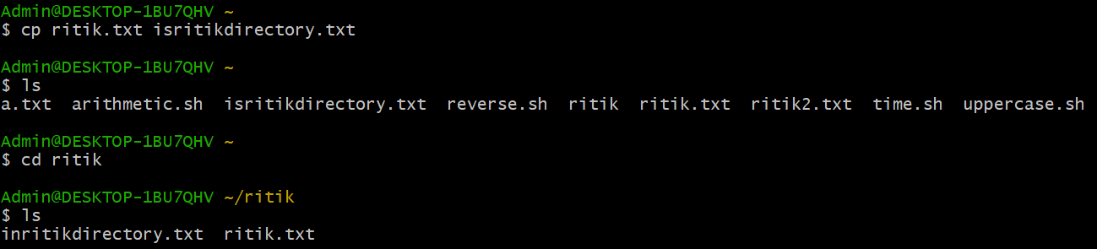

**Que 18 Write the linux command to move a file to some different location.**

**mv Command**

The [mv](https://www.javatpoint.com/linux-mv) command is used to move a file or a directory form one location to another location.

Syntax: **mv <file name> <directory path>**

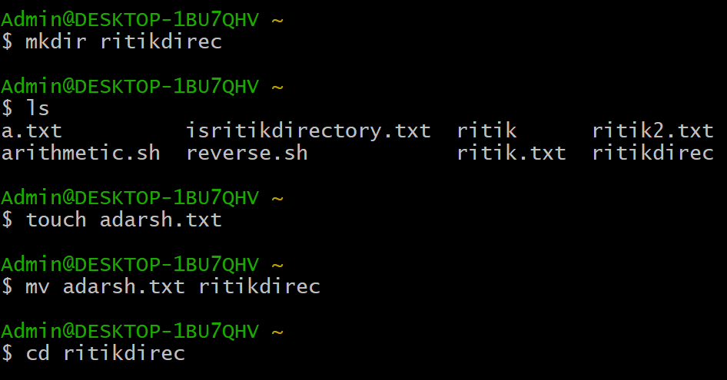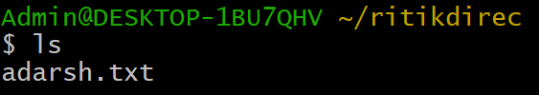

**Que 19 Write the linux command to compare the contents of two files**

**1.Compare Commands**

**cmp** command in Linux/UNIX is used to compare the two files byte by byte and helps you to find out whether the two files are identical or not.

· When cmp is used for comparison between two files, it reports the location of the first mismatch to the screen if difference is found and if no difference is found *i.e* the files compared are identical.

· cmp displays no message and simply returns the prompt if the the files compared are identical.

**Syntax:**

**cmp [OPTION]... FILE1 [FILE2]**

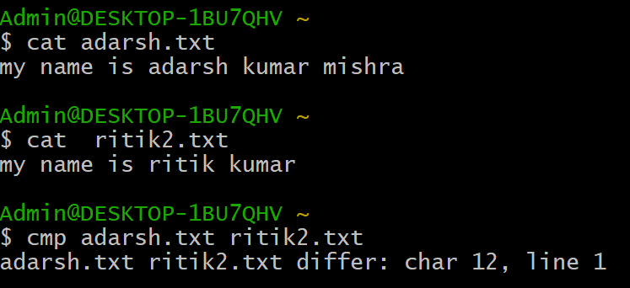

**2.Comm Command**

comm compare two sorted files line by line and write to standard output; the lines that are common and the lines that are unique.

Syntax :**$comm [OPTION]... FILE1 FILE2**

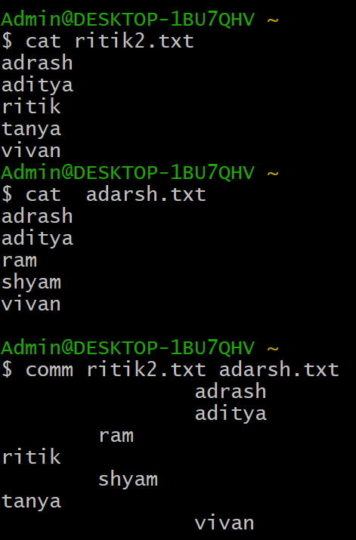

**Diff Command**

diff stands for **difference**. This command is used to display the differences in the files by comparing the files line by line. Unlike its fellow members, [cmp](https://www.geeksforgeeks.org/cmp-command-linux-examples/) and [comm](https://www.geeksforgeeks.org/comm-command-linux-examples/), it tells us which lines in one file have is to be changed to make the two files identical.

The important thing to remember is that **diff** uses certain **special symbols** and **instructions** that are required to make two files identical. It tells you the instructions on how to change the first file to make it match the second file.

**Special symbols are:**

**a : add**

**c :** **change**

**d :** **delete**

**Syntax :**

**diff [options] File1 File2**

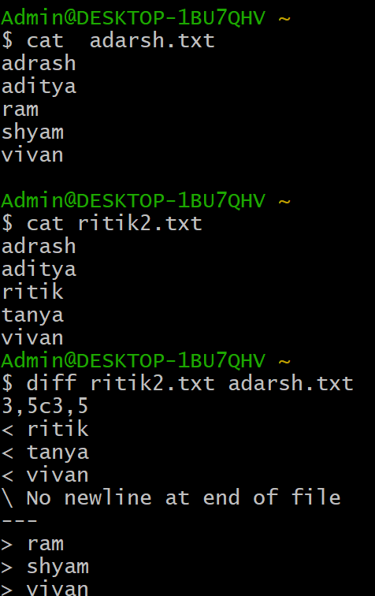

**Que 20 Write the linux command to count the number of words, lines and sentences in the file**

**WC Command**

The wc command allows you to count the number of lines, words, characters, and bytes of each given file or standard input and print the result.

The syntax for the wc command is as follows: **wc OPTION... [FILE]...**

The options below allow you to select which counts are printed.

* -l, --lines - Print the number of lines.
* -w, --words - Print the number of words.
* -m, --chars - Print the number of characters.
* -c, --bytes - Print the number of bytes.
* -L, --max-line-length - Print the length of the longest line.

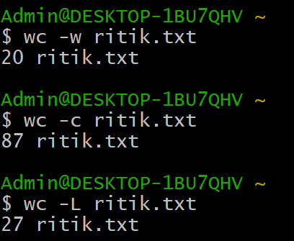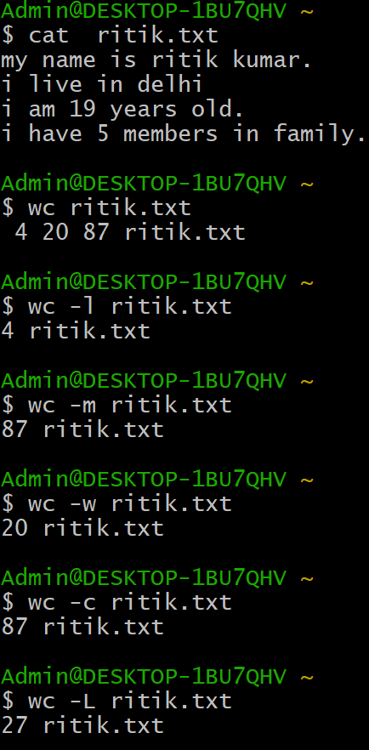

**Que 21 Write the linux command to see the data in octal format.**

**od command**

Od command in Linux is used to convert the content of input in different formats with octal format as the default format

* **-b Option :It displays the contents of input in octal format**
* **-c Option :**It displays the contents of input in character format.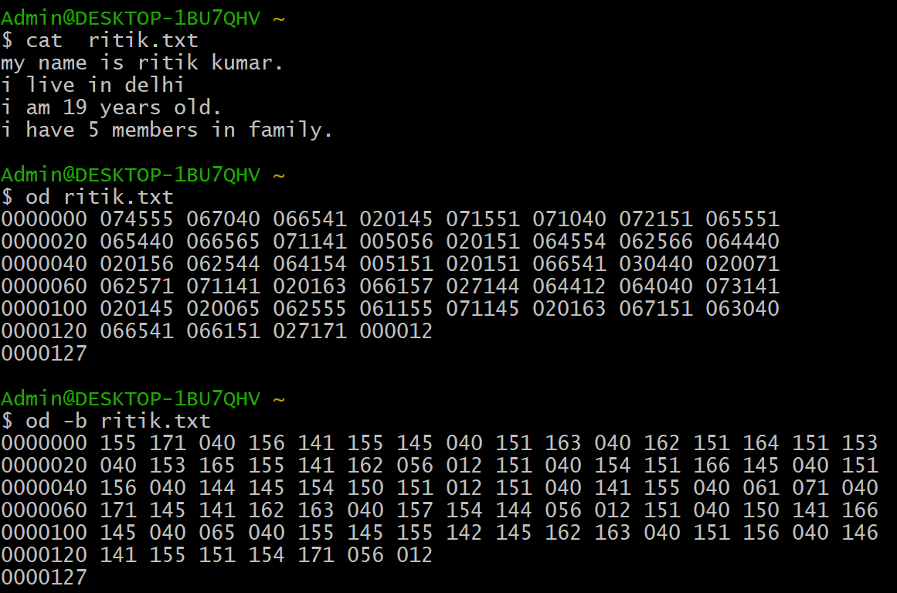

### 

### 

### **Que 22 Write the linux command to give the alias name.**

### **Alias**

### Aliases are used to customize the shell session interface. Using alias, frequently-used commands can be invoked using a different, preferred term; and complex or commonly- used options can be used as the defaults for a given command.

**Syntax:alias r=’ls’**

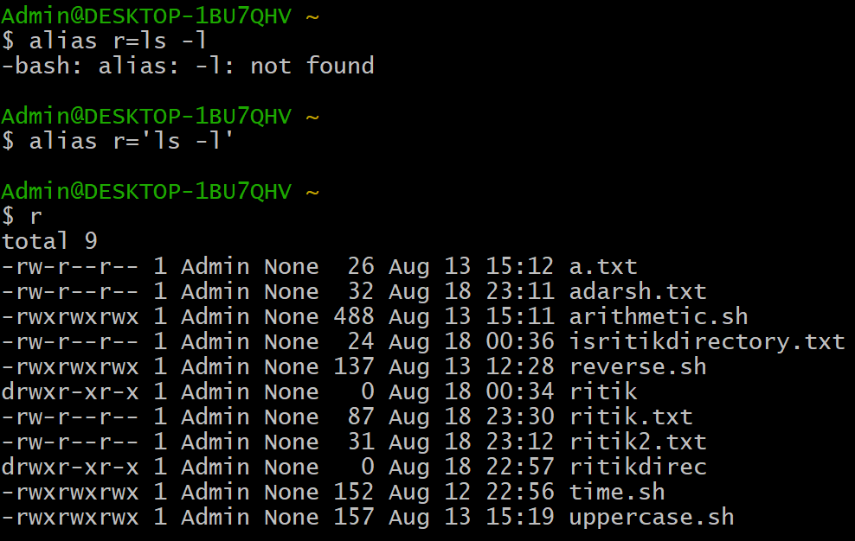

**Que 23 Write the linux command to view the existing aliases.**

**Alias -p option :** This option prints all the defined aliases is reusable format.

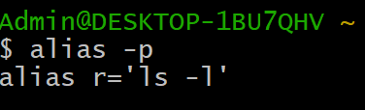

**Que 24 Write the linux command to unalias the exiting alias name.**

**Unalias** : Removing an existing alias is known as unaliasing.

**Syntax:**

**unalias [alias name]**

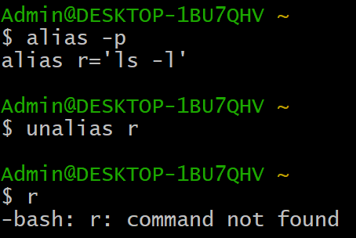

**Que 25 Write the linux command to display the hostname of the system.**

**Hostname command**

We simply write hostname to display host system

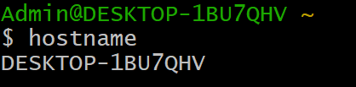

Que 26 Write the linux command to get information about the operating System.

**Uname -a i**s used to get information about the operating system



Que 27 Write the linux command to display unique contents of a file.

The **uniq command** in Linux is a command-line utility that reports or filters out the repeated lines in a file.

Syntax : uniq filename

**Uniq -c option :** It tells the number of times a line was repeated.

**uniq -d option** : It only prints the repeated lines.

**Uniq -u option :** It prints only the unique lines.

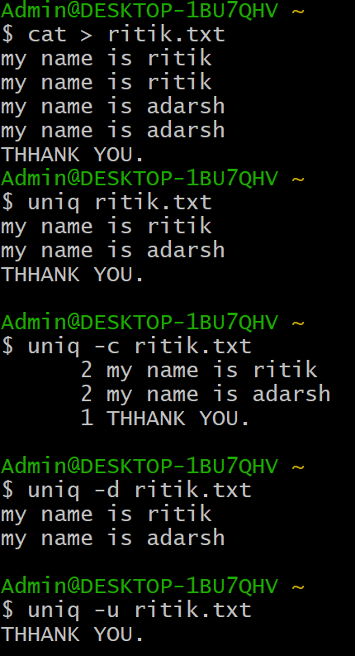

**Que 28 Write the linux command to view first 5 lines of a file.**

**Head -5 filename**

command is used to view first 5 lines of a file

Ex: **head -5 ritik.txt**

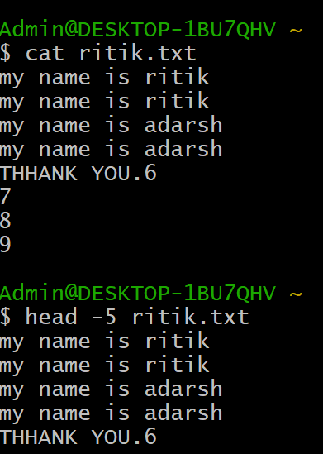

**Que 29 Write the linux command to view last 20 lines of a file.**

**Tail command**

Tail command is used to print last line in file

So for last 20 lines

We use command syntax : **tail -20 file name** 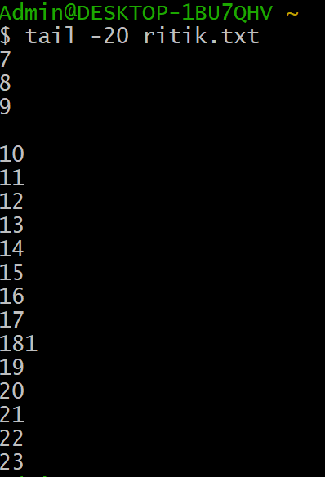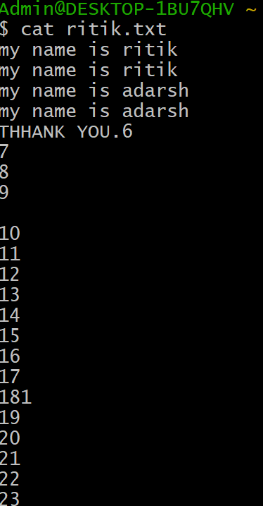

**Que 30 Write the linux command to extract specific column and field from a file.**

**awk '{print $1, $3}' file1.txt**

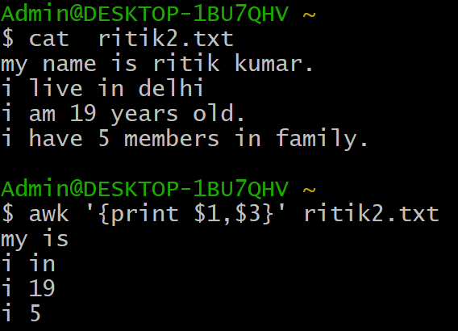

**Que 31 Write the linux command to merge two files vertically.**

**$paste:** It is used to merge two files line by line.

**Syntax:** **paste [file_name1] [sile_name2]**

**Example:**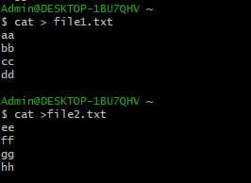

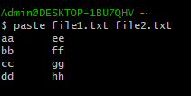

**$paste –d:** It is used to specify a different delimiter.

**Syntax:** **paste –d / [file_name1] [sile_name2]**

**Example:**

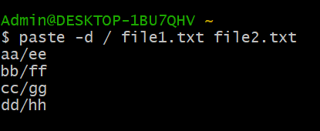

**$paste:** It is used to merge two files vertically.

**Syntax:** **paste [file_name1] [file_name2]>[sile_name3]**

**Example:**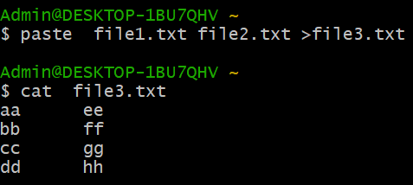

**Que 32 Write the linux command to sort a file.**

**$sort:** It is used to sorts the contents of a text file, line by line.

**Syntax:** **sort [file_name1]**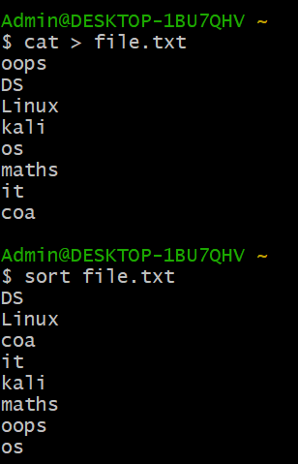

**Example:**

**$sort –r:** It is used to sorting in reverse order.

**Syntax:** **sort –r [file_name1]**

**Example:**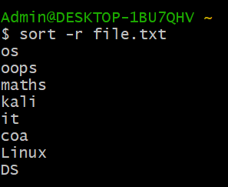

**$sort –n:** It is used to sort a file numerically.

**Syntax:** **sort –n [file_name1]**

**Example:**

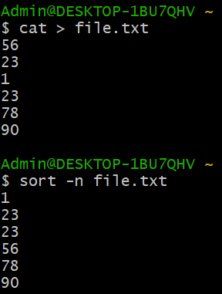

**Que 33 Write the linux command to find any character and replace it with some other character.**

**Sed command:**

Sed is a Stream Editor used for modifying the files in unix (or linux). Whenever you want to make changes to the file automatically, sed comes in handy to do this. Most people never learn its power; they just simply use sed to replace text. You can do many things apart from replacing text with sed. Here I will describe the features of sed with examples.

Consider the below text file as an input.

**1. Replacing or substituting string**

Sed command is mostly used to replace the text in a file. The below simple sed command replaces the word "unix" with "linux" in the file.

**sed 's/unix/linux/' file.txt**

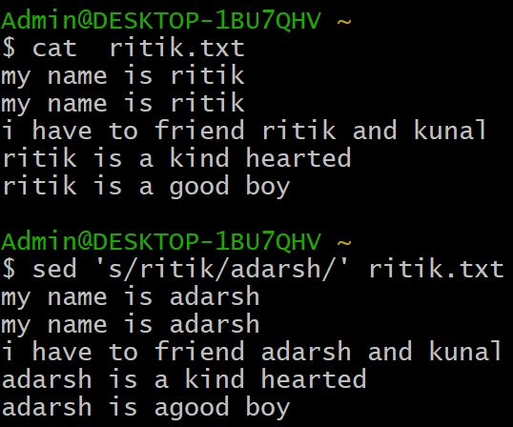

**2. Replacing the nth occurrence of a pattern in a line.**

Use the /1, /2 etc flags to replace the first, second occurrence of a pattern in a line. The below command replaces the second occurrence of the word "unix" with "linux" in a line.

**sed 's/unix/linux/2' file.txt**

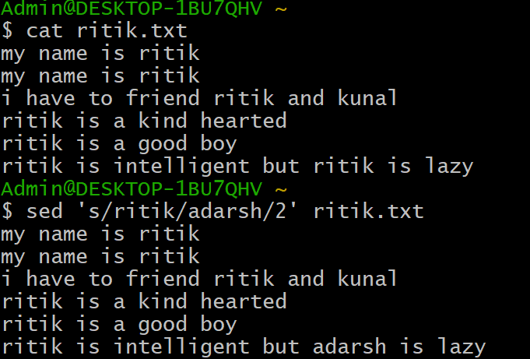

**3. Replacing all the occurrence of the pattern in a line.**

The substitute flag /g (global replacement) specifies the sed command to replace all the occurrences of the string in the line.

**sed 's/unix/linux/g' file.txt**

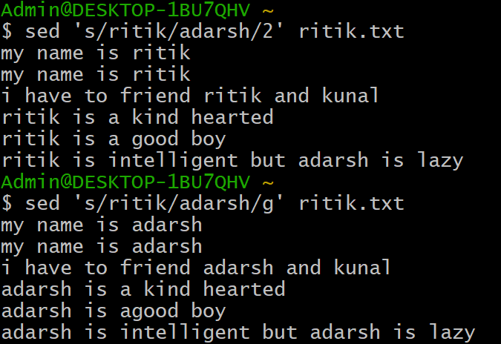

**4. Replacing from nth occurrence to all occurrences in a line.**

Use the combination of /1, /2 etc and /g to replace all the patterns from the nth occurrence of a pattern in a line.

**sed 's/a/c/3g' file.txt**

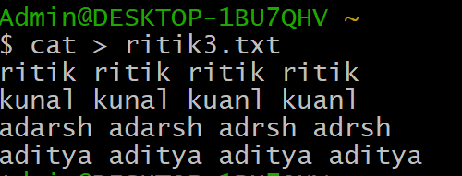

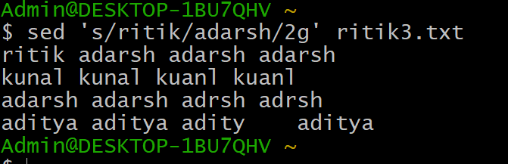

**Que 34 Write the linux command to change the permission of an existing file in relative manner**

**Relative or symbolic Mode**

In the symbolic mode, you can modify permissions of a specific owner. It makes use of

mathematical symbols to modify the file permissions.

Operator Description

+ Adds a permission to a file or directory

- Removes the permission

= Sets the permission and overrides the permissions set earlier.

There are three users to give permissions user,other ,group represented u,o,g respectively

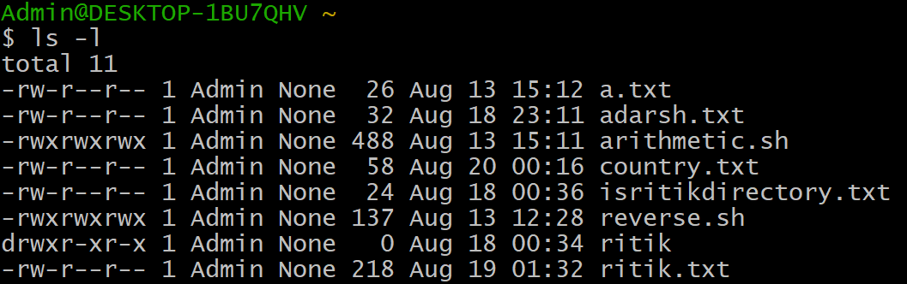

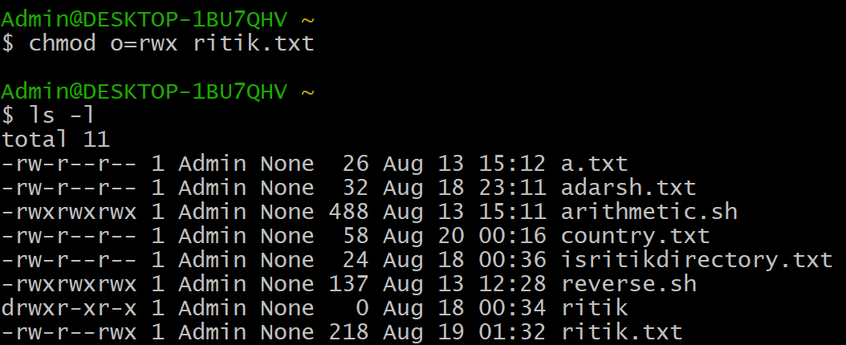

**Que 35 Write the linux command to change the permission of an existing file in absolute manner**

**Absolute (Numeric) Mode**

In this mode, file permissions are not represented as characters but a three-digit octal

number.

Number Permission Type Symbol

0 No Permission ---

1 Execute --x

2 Write -w-

3 Execute + Write -wx

4 Read r--

5 Read + Execute r-x

6 Read +Write rw-

7 Read + Write +Execute rwx

Let see the chmod command in action.

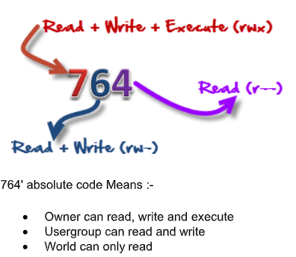

**Syntax : chmod 777 ritik.txt**

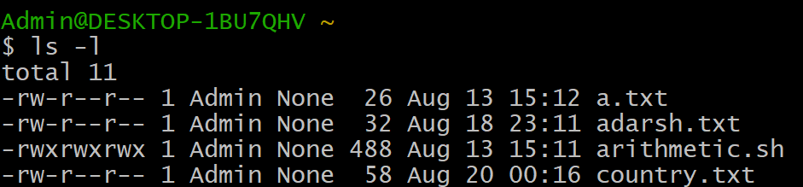

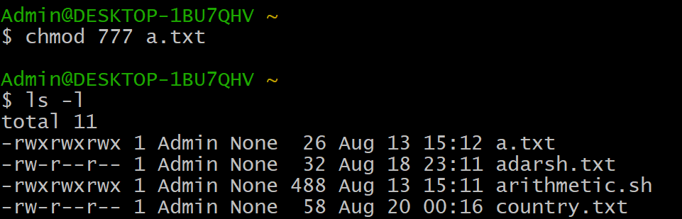

**Que 36 Write the linux command to create a hard link of a file Linux Lab 3 NAME COURSE Roll No**

The ln command make links between files. By default, ln makes hard links.

Here are a few important aspects of hard links:

* If the original file is deleted, the file data can still be accessed through other hard links.
* If the original file is moved, hard links still work.
* A hard link can only refer to a file on the same file system.
* The *inode* and file data are permanently deleted when the number of hard links is zero.

**ln** **{source}** **{link}**

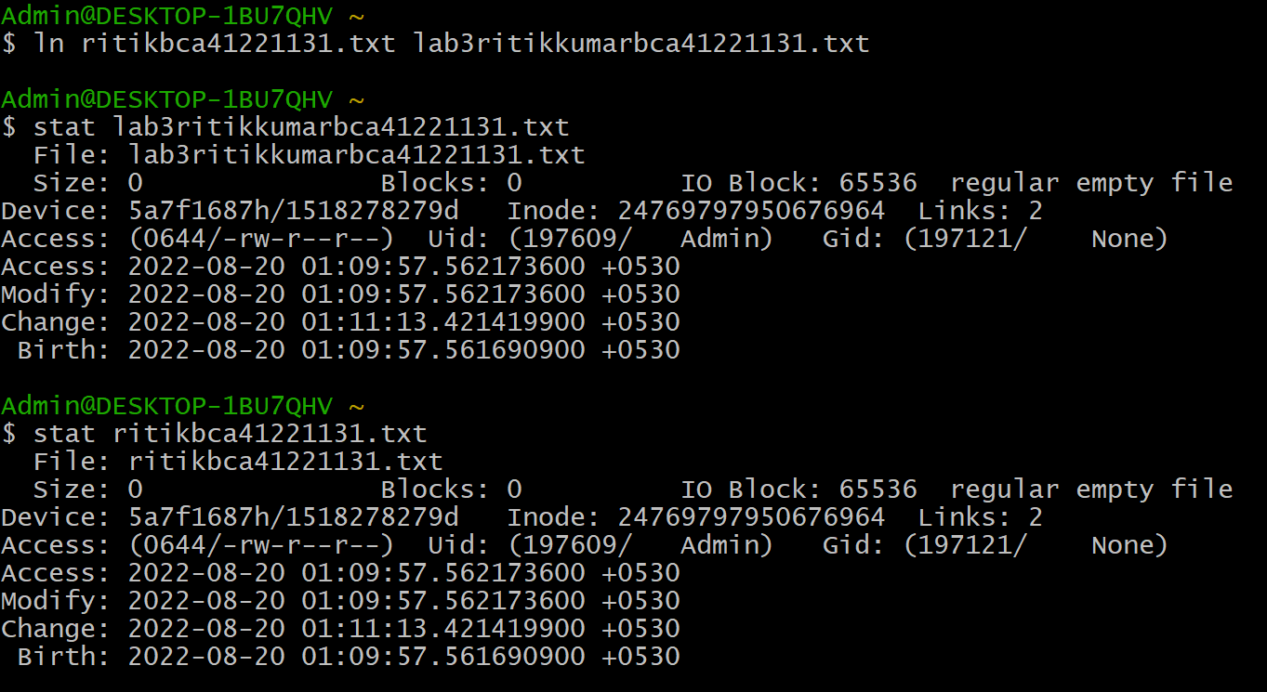

### 

### 

### **Que 37 Write the linux command to create a soft link of a file as well as directory**

### **Soft (Symbolic) Links**

**A soft link, sometimes called a *symbolic link* or *symlink*, points to the location or *path* of the original file. It works like a hyperlink on the internet.**

**Here are a few important aspects of a soft link:**

* **If the symbolic link file is deleted, the original data remains.**
* **If the original file is moved or deleted, the symbolic link won’t work.**
* **A soft link can refer to a file on a different file system.**
* **Soft links are often used to quickly access a frequently-used file without typing the whole location.**

**Syntax: ls -s sourcefilename destinationfilename**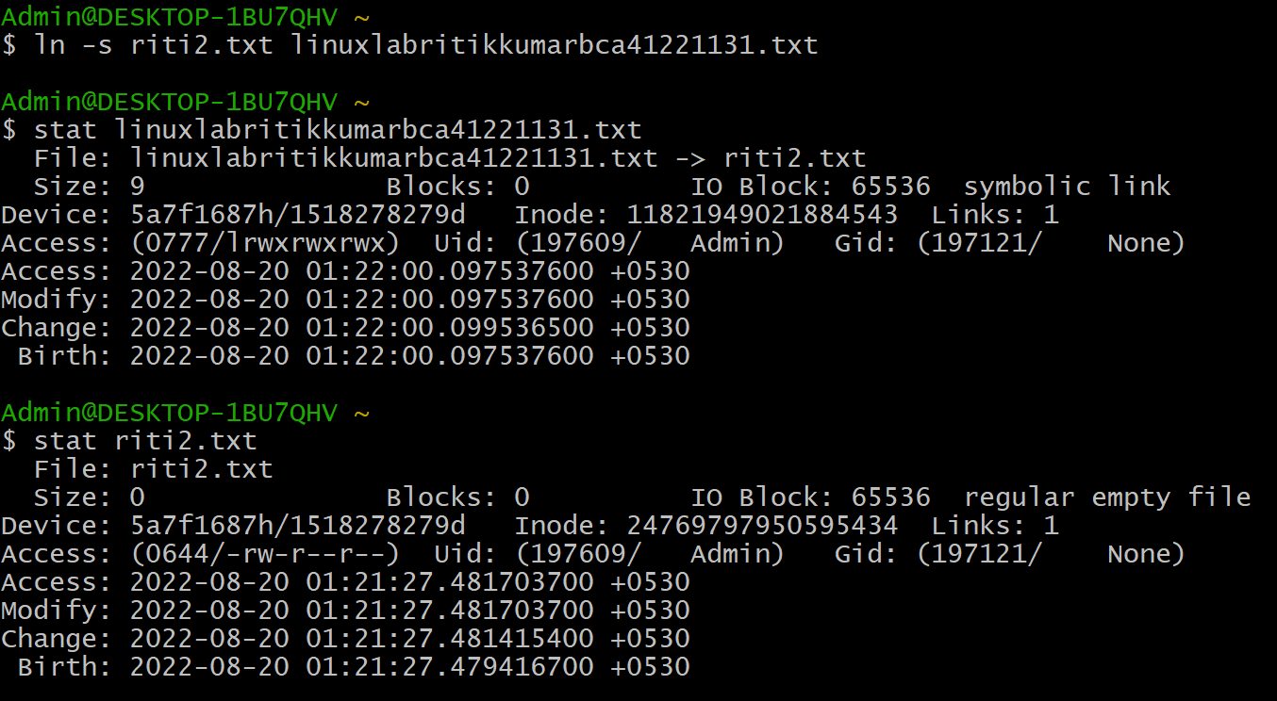

**Que 38 Write the linux command to search for specific pattern in a file.**

**Grep command**

Grep is the frequently used command in Unix (or Linux). Most of us use grep just for finding the words in a file. The power of grep comes with using its options and regular expressions. You can analyze large sets of log files with the help of grep command.

Grep stands for Global search for Regular Expressions and Print.

The basic syntax of grep command is.

**1. Simple Search for a string in a file**

**grep "Error" logfile.txt**

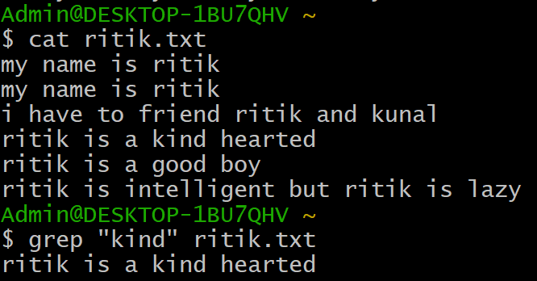

**2.Case insensitive search :**

The -i option enables to search for a string case insensitively in the given file. It matches the words like “UNIX”, “Unix”, “unix”.

**Syntax:- grep -i "UNix" geekfile.txt**

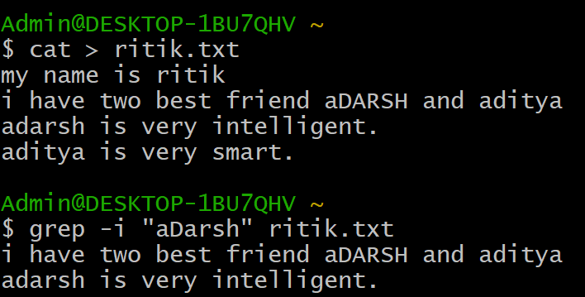

**3. Displaying the count of number of matches :** We can find the number of lines that matches the given string/pattern

**Syntax:- grep -c "unix" geekfile.txt**

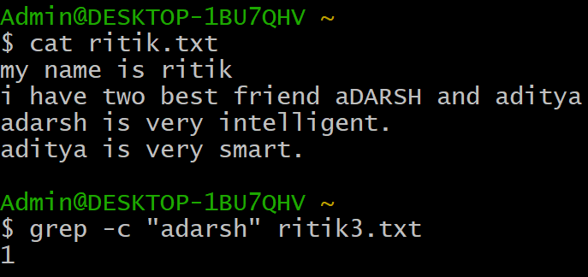

**4. Show line number while displaying the output using grep -n :** To show the line number of file with the line matched.

**grep -n "unix" geekfile.txt**

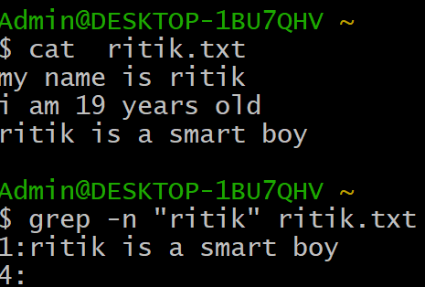

**5. Display the file names that matches the pattern : We can just display the files that contains the given string/pattern.**

**grep -l "unix" * or grep -l "unix" f1.txt f2.txt f3.xt f4.txt**

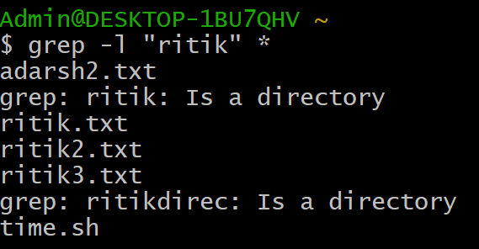

**Que 39 Write the linux command to replace any character/string with specified character/string using sed Command**

**Sed command:**

Sed is a Stream Editor used for modifying the files in unix (or linux). Whenever you want to make changes to the file automatically, sed comes in handy to do this. Most people never learn its power; they just simply use sed to replace text. You can do many things apart from replacing text with sed. Here I will describe the features of sed with examples.

Consider the below text file as an input.

**1. Replacing or substituting string**

Sed command is mostly used to replace the text in a file. The below simple sed command replaces the word "unix" with "linux" in the file.

**sed 's/unix/linux/' file.txt**



**2. Replacing the nth occurrence of a pattern in a line**.

Use the /1, /2 etc flags to replace the first, second occurrence of a pattern in a line. The below command replaces the second occurrence of the word "unix" with "linux" in a line.

**sed 's/unix/linux/2' file.txt**



**3. Replacing all the occurrence of the pattern in a line**.

The substitute flag /g (global replacement) specifies the sed command to replace all the occurrences of the string in the line.

**sed 's/unix/linux/g' file.txt**



**4. Replacing from nth occurrence to all occurrences in a line.**

Use the combination of /1, /2 etc and /g to replace all the patterns from the nth occurrence of a pattern in a line.

**sed 's/a/c/3g' file.txt**





**Que 41 Write the linux command to show the use of awk Command**

**Awk command**

Awk is one of the most powerful tools in Unix used for processing the rows and columns in a file. Awk has built in string functions and associative arrays. Awk supports most of the operators, conditional blocks, and loops available in C language.

AWK Operations:

(a) Scans a file line by line

(b) Splits each input line into fields

(c) Compares input line/fields to pattern

(d) Performs action(s) on matched lines

The basic syntax of AWK:

awk 'BEGIN {start_action} {action} END {stop_action}' filename

awk options 'selection _criteria {action }' Filename

**1.** **awk '{print}' file1.txt**

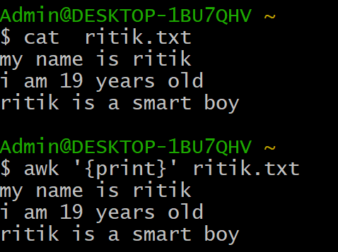

**2.**  **awk '/manager/ {print}' file1.txt**

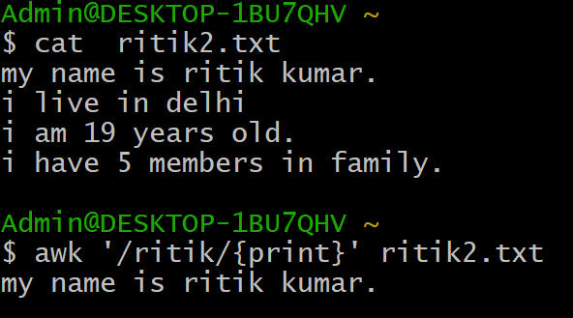

**3. awk '{print $1, $3}' file1.txt**



**Que 42 Write the linux command to list the processes for the current shell(ps).**

**Ps command**

It help to display current process in the system.

syntax:-Ps -ef

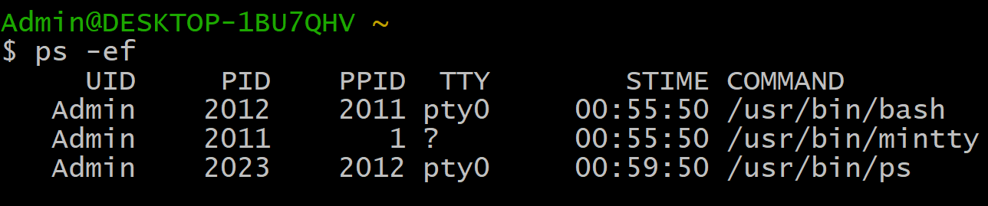

**Que 43 Write the linux command to display detailed information about processes.**

**Ps command**

It help to display current process in the system.

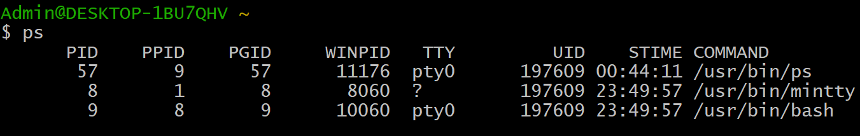

**Que 44 Write the linux command to stop any currently running process**

**Kill command**

Kill command is used to kill to stop the currently running process.

**Syntax:- kill pid**

**Ex:- kill 2012**

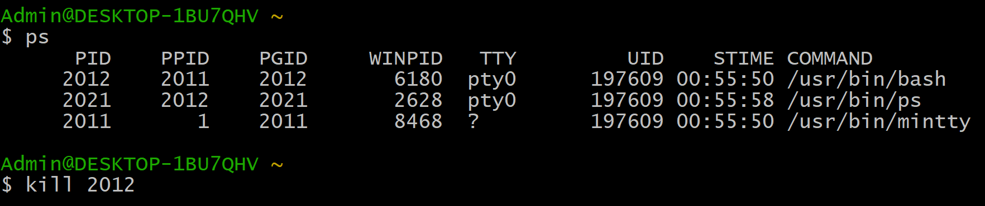

**Que 45 Write the linux command to Kill a process**

**1.Kill command** :Kill command is used to kill to stop the currently running process.

**Syntax:- kill pid**

**Ex:- kill 2012**



**Kill forcfully : To kill a command forcefully. Syntax:kill -9 pid**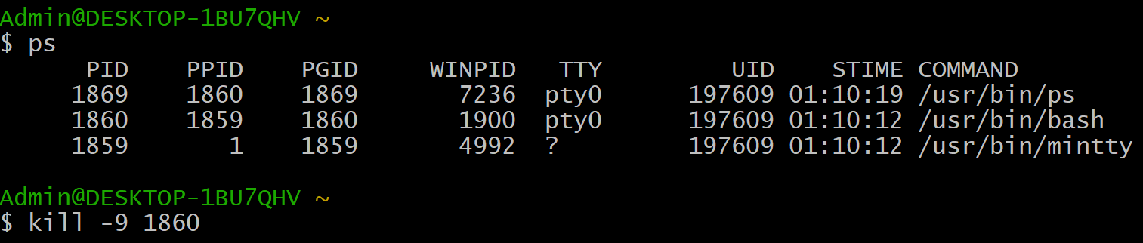

**Que 46 Write the linux command to create a tar file**

1. Run tar command to create an archived named file.tar.gz for given directory name by running: tar -cvf file.tar.gz directory
2. Verify tar.gz file using the ls command and tar command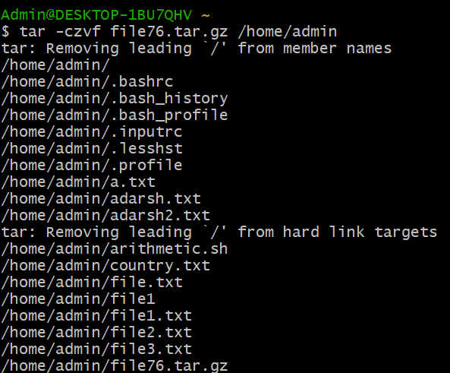

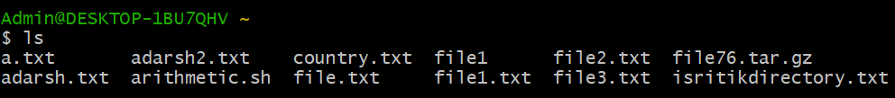

**Que 47 Write the linux command to create a Zip file and Unzip it**

**Bzip command**

For creating a zip file

**Syntax: bzip2 filename**

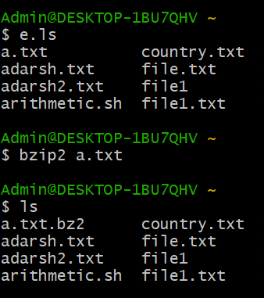

**Unzip : for unzip the file we use syntax : unzip2 filename** 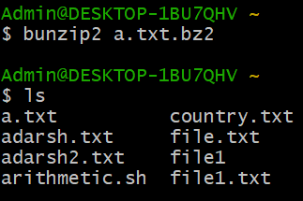

**Que 48 Write a shell script to find the largest of two numbers**

**PROGRAM:**

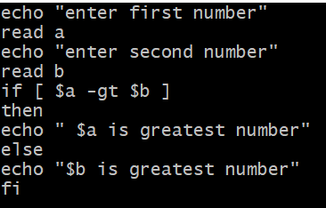

**OUTPUT:**

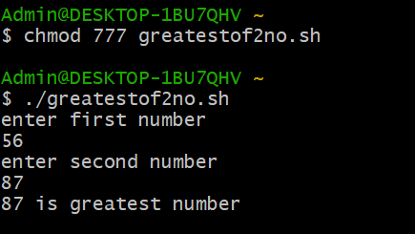

**Que 49 Write a shell script to check whether a number is even or odd**

**PROGRAM:**

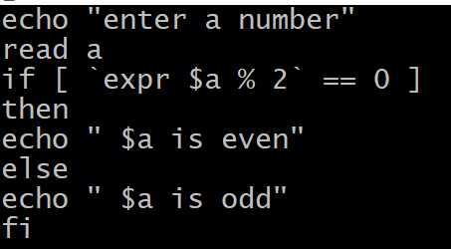

**OUTPUT:**

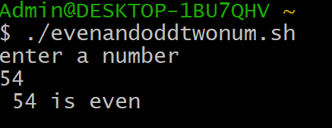

**Que 50 Write a shell script to find largest of three given number.**

**PROGRAM:**

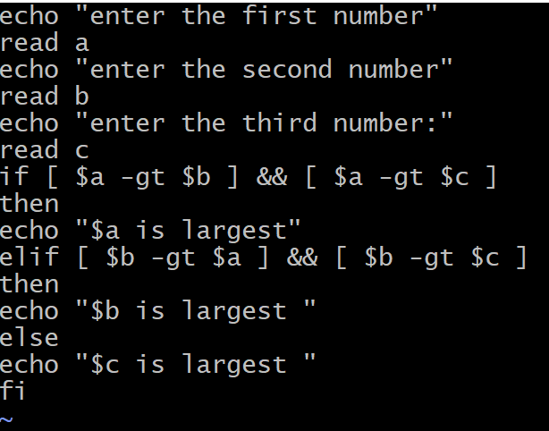

**OUTPUT:**

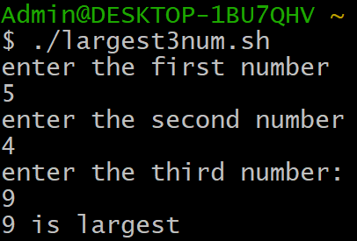

**Que 51Write a shell script to greet the user according to the week of the day.**

**PROGRAM:**

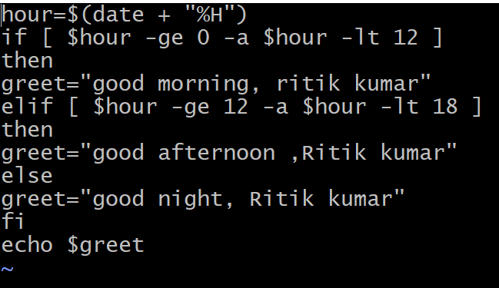

**OUTPUT:**

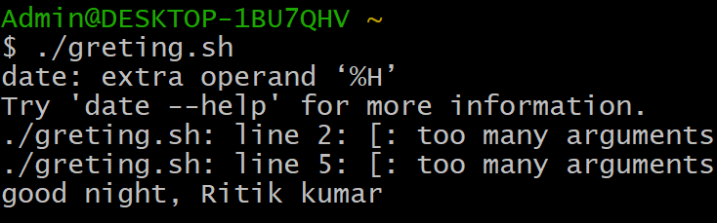

**Que 52 Write a shell script to display the number of vowels and consonants in a string**

**PROGRAM:**

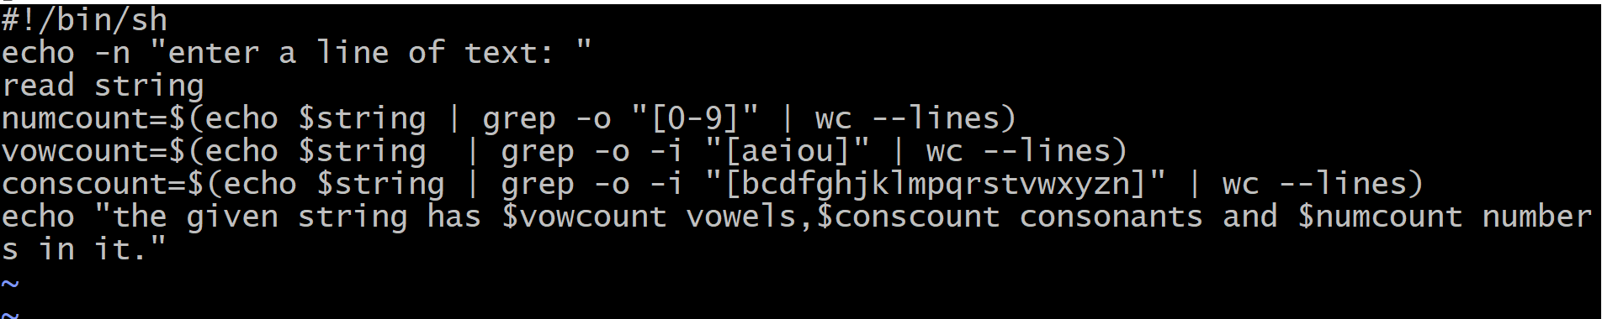

**OUTPUT:**

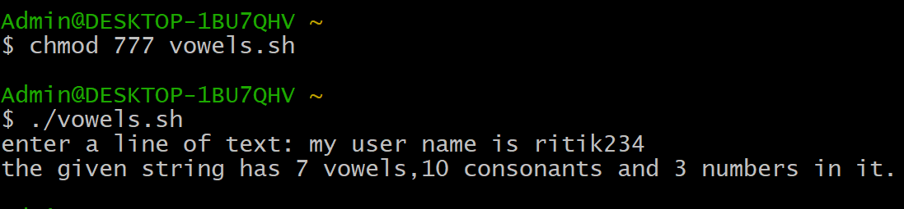

**Que 53 Write a shell script to perform arithmetic operation using case---esac.**

**PROGRAM:**

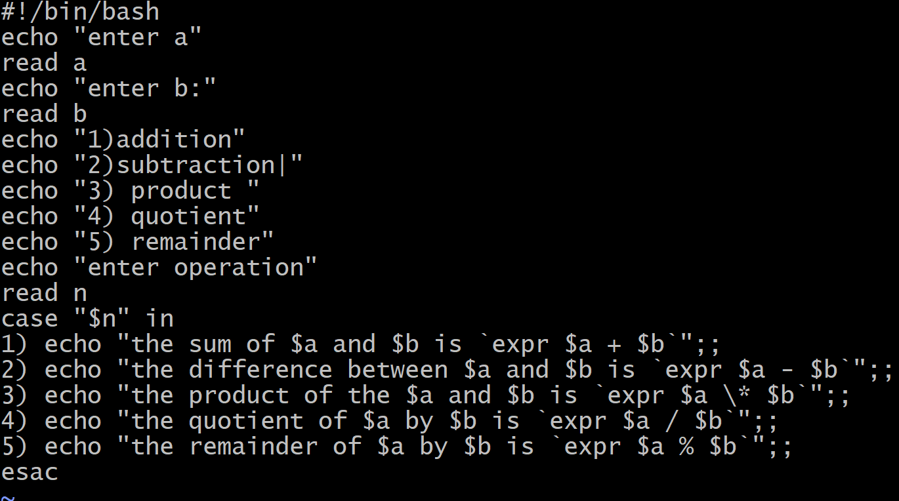

**OUTPUT:**

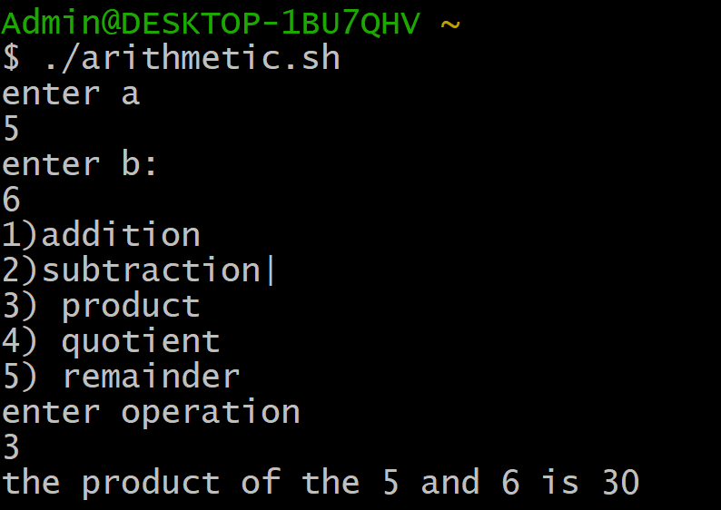

**Que 54 Write a shell script to count words, lines and characters in a file**

**PROGRAM:**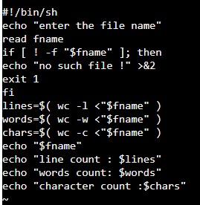

**OUTPUT:**

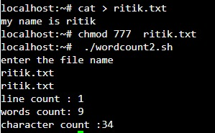

**Que 55 Write a shell script to check whether the year entered is leap or not**

**PROGRAM:**

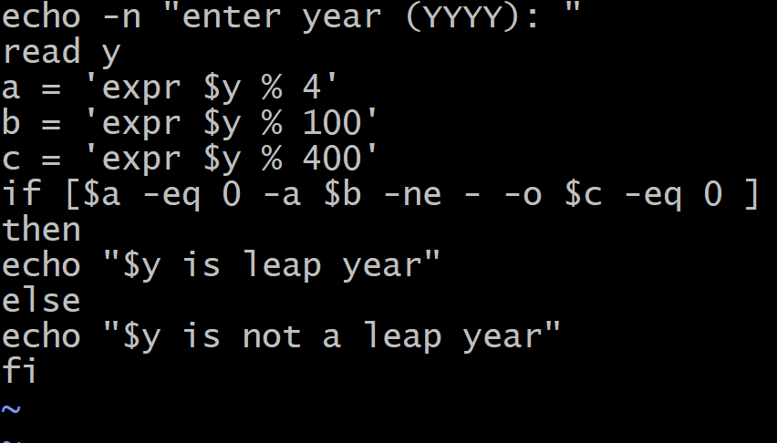

**OUTPUT:**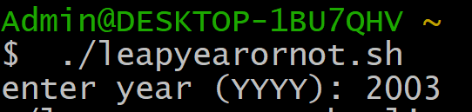

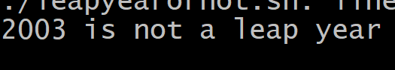

**Que 56 Write a shell script to find factorial of a number.**

**PROGRAM:**

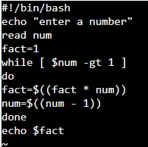

**OUTPUT:**

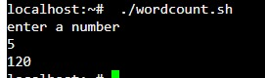

**Que 57 Write a shell script to generate a multiplication table**

**PROGRAM:**

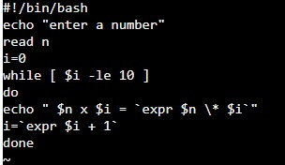

**OUTPUT:**

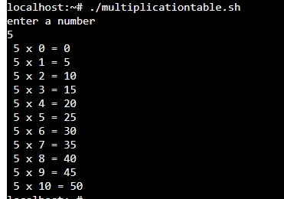

**Que 58 Write a shell script to add the digits of a number**

**PROGRAM:**

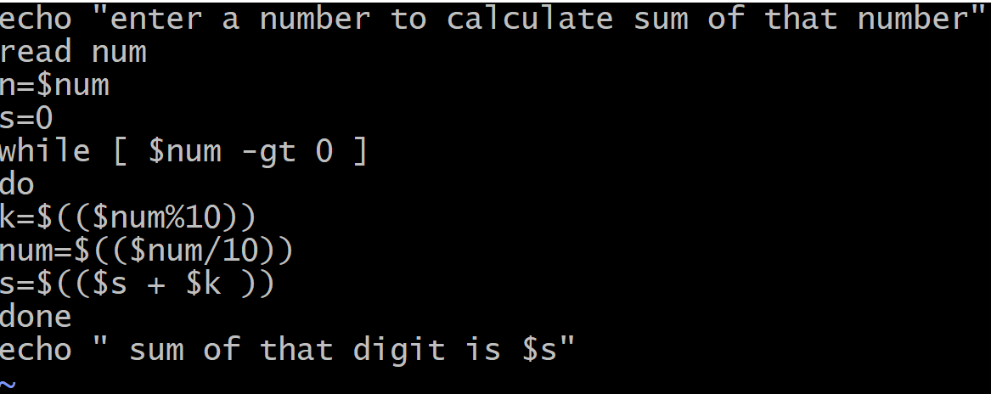

**OUTPUT:**

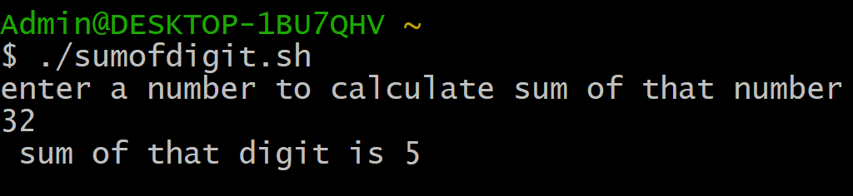

**Que 59 Write a shell script to reverse a string.**

**PROGRAM:**

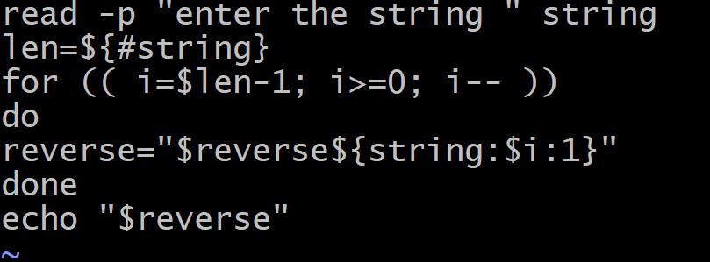

**OUTPUT:**

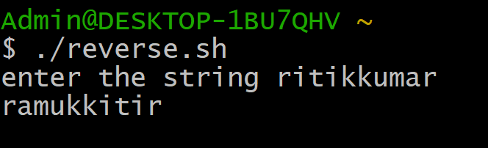

**Que 60 Write a shell script to check whether a number entered is prime or not**

**PROGRAM:**

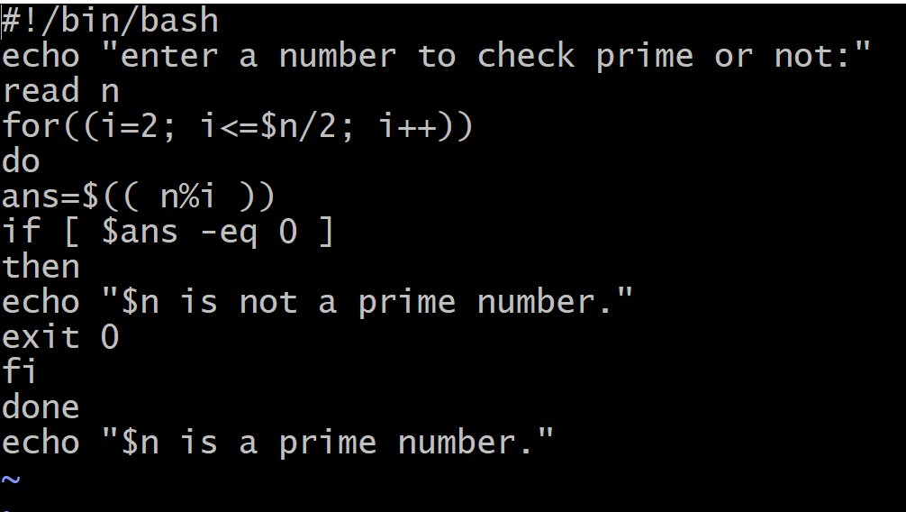

**OUTPUT:**



